Invisibles 13 School
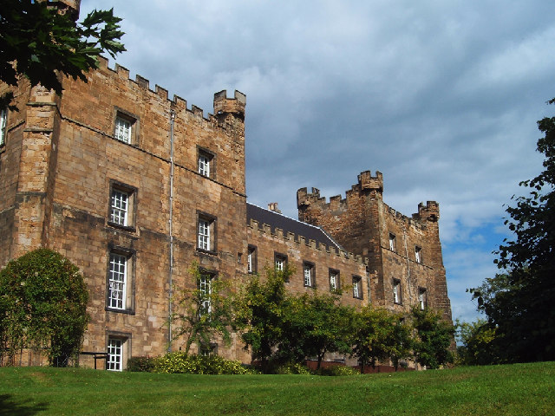
Lumley Castle
15 July 2013
Participant list
Last name |  | First name |  |  | Institution
Abada |  | Asmaa |  |  | Laboratoire de Physique Théorique
Alonso |  | Rodrigo |  |  | UAM-IFT
Alvarez |  | enrique |  |  | universidad autonoma de madrid
Arcadi |  | Giorgio |  |  | University of Goettingen
Archidiacono |  | Maria |  |  | Aarhus University
Baek |  | Seungwon |  |  | Korea Institute of Advanced Study
Ballett |  | Peter |  |  | IPPP, Durham University
Barrow |  | Peter |  |  | UZH (University of Zurich)
Baudis |  | Laura |  |  | University of Zurich
Bergström |  | Johannes |  |  | KTH Royal Institute of Technology
Blennow |  | Mattias |  |  | KTH
Boehm |  | Celine |  |  | IPPP, Durham University
Bozorgnia |  | Nassim |  |  | Max-Planck-Institut für Kernphysik
Brivio |  | Ilaria |  |  | Universidad Autónoma de Madrid
Capelli |  | Silvia |  |  | Universita` e Sez. INFN di Milano Bicocca
Choubey |  | Sandhya |  |  | Harish-Chandra Research Institute
Choudhary |  | Brajesh |  |  | University of DELHI
Cirelli |  | Marco |  |  | IPhT CNRS Saclay
Cirigliano |  | Vincenzo |  |  | Los Alamos National Laboratory
Cline |  | Jim |  |  | McGill University
Contreras |  | Hugo |  |  | Columbia University
Cooley |  | Jodi |  |  | Southern Methodist University
Covi |  | Laura |  |  | Institute for theoretical Physics
Cowan |  | Glen |  |  | Royal Holloway University of London
Davidson |  | Sacha |  |  | IPN de Lyon
Davis |  | Jonathan |  |  | IPPP, Durham University
De Romeri |  | Valentina |  |  | IFIC Valencia
De Rujula |  | Alvaro |  |  | CERN
De Simone |  | Andrea |  |  | SISSA, Cern
Decowski |  | Patrick |  |  | Nikhef & University of Amsterdam
Dhen |  | Mikaël |  |  | Universite Libre de Bruxelles (ULB)
Dolan |  | Matthew |  |  | IPPP Durham
Domcke |  | Valerie |  |  | DESY
Ellis |  | John |  |  | King's College London/CERN
Elmer |  | Martin |  |  | IPN Lyon
Evans |  | Justin |  |  | University of Manchester
Fernandez Martinez |  | Enrique |  |  | UAM
Figueiredo |  | Antonio |  |  | CFTP and LPC Clermont
Fischer |  | Vincent |  |  | CEA Saclay, IRFU, SPP
Fox |  | Patrick |  |  | Fermilab
Frenk |  | Carlos |  |  | Durham University
Frigerio |  | Michele |  |  | Laboratoire Charles Coulomb
Gavela |  | Belen |  |  | UAM-IFT
Gelmini |  | Graciela |  |  | University of California Los Angeles
Giusarma |  | Elena |  |  | IFIC-Universidad de Valencia
Goetzke |  | Luke |  |  | Columbia University
Gonzalez Fraile |  | Juan |  |  | Universitat de Barcelona
Gonzalez-Garcia |  | Maria Concepcion |  |  | U. Barcelona & Stony Brook Univ
Green |  | Anne |  |  | University of Nottingham
Grinstein |  | Benjamin |  |  | UC San Diego
Hannestad |  | Steen |  |  | Aarhus University
Hansen |  | Rasmus Sloth |  |  | Aarhus University
Harrison |  | Paul |  |  | Warwick University/CERN
Hernandez |  | Daniel |  |  | ICTP
Hernandez |  | Pilar |  |  | University of Valencia
Herrero |  | Juan |  |  | Universidad de Valencia, IFIC - CSIC
Herrero |  | Maria Jose |  |  | UAM/IFT
Hierro Rodríguez |  | Ignacio Miguel |  |  | University of Zaragoza
Incandela |  | Joe |  |  | UCSB/CERN
Jaeckel |  | Joerg |  |  | ITP Heidelberg
Jakobsen |  | Ulla |  |  | ITN Invisibles
Kajita |  | Takaaki |  |  | Institute for Cosmic Ray Research, Univ. of Tokyo
Kamenik |  | Jernej |  |  | Jozef Stefan Institute, Ljubljana
Kanshin |  | Kirill |  |  | INFN Padova Section
Kekic |  | Marija |  |  | Instituto de Fisica Corpuscular CSIC/UV
Khalil |  | Shaaban |  |  | Center for Theoretical Physics, Zewail city of science and technology
King |  | Sophie |  |  | University of Southampton
King |  | Steve |  |  | University of Southampton
Laura |  | Lopez Honorez |  |  | VUB
Lesgourgues |  | Julien |  |  | CERN and Institut de Physique Theorique, Lausanne
Lopez Pavon |  | Jacobo |  |  | SISSA
Losada |  | Marta |  |  | Universidad Antonio Narino
Lucente |  | Michele |  |  | Laboratoire de Physique Théorique
Luhn |  | Christoph |  |  | University of Durham
Machado |  | Pedro |  |  | Sao Paulo U. going to IFT-Madrid
Mambrini |  | Yann |  |  | LPT Orsay
Marrodán Undagoita |  | Teresa |  |  | Max-Planck-Institut für Kernphysik
Mayani |  | Daniel |  |  | UZH
McCabe |  | Christopher |  |  | IPPP
Melgarejo |  | Antonio |  |  | Columbia University
Mena |  | Olga |  |  | IFIC-CSIC/UV
Mention |  | Guillaume |  |  | CEA Saclay
Merle |  | Alexander |  |  | University of Southampton
Merlo |  | Luca |  |  | Universidad Autónoma de Madrid
Meroni |  | Aurora |  |  | SISSA
Mirizzi |  | Alessandro |  |  | II Institute for Theoretical Physics
Mitra |  | Manimala |  |  | IPPP, Durham University
Neder |  | Thomas |  |  | University of Southampton
Niro |  | Viviana |  |  | University of Barcelona
No |  | Jose Miguel |  |  | University of Sussex
Panci |  | Paolo |  |  | CP3-Origins, University of Southern Denmark
Parke |  | Stephen |  |  | Fermilab MS106
Pascoli |  | Silvia |  |  | IPPP - Durham University
Passera |  | Massimo |  |  | INFN Padova
Pospelov |  | Maxim |  |  | Perimeter Institute for Theoretical Physics
Quigg |  | Chris |  |  | Fermi National Accelerator Laboratory
Rama |  | Krishnan |  |  | Warwick University
Rigolin |  | Stefano |  |  | Universita' di Padova e INFN Padova
Rius |  | Nuria |  |  | IFIC, Valencia University-CSIC
Robertson Sotelo |  | Denis Stefan |  |  | Institute of Physics of Sao Paulo University (IF-USP)
Ross |  | Graham |  |  | University of Oxford
Ross-Lonergan |  | Mark |  |  | IPPP - Durham University
Salvado Serra |  | Jordi |  |  | University of Wisconsin-Madison
Saviano |  | Ninetta |  |  | Hamburg University
Schewtschenko |  | Jascha |  |  | IPPP, Durham University
Schmidt |  | Benjamin |  |  | KIT
Schwetz |  | Thomas |  |  | Max-Planck-Institut fuer Kernphysik
Siebenborn |  | Bernhard |  |  | KIT
Stuart |  | Alexander |  |  | University of Southampton
Tarhini |  | Ahmad |  |  | IPNL (Institut de Physique Nucléaire de Lyon) University Lyon 1
Teixeira |  | Ana M. |  |  | LPC Clermont
Timonen |  | Tiina |  |  | Universidad Autónoma de Madrid
Toma |  | Takashi |  |  | IPPP, Durham University
Tytgat |  | Michel |  |  | Universite Libre de Bruxelles (ULB)
Vincent |  | Aaron |  |  | UVEG
Wang |  | Wei |  |  | College of William and Mary
Watanabe |  | Atsushi |  |  | Max-Planck-Institut fuer Kernphysik
Weiland |  | Cedric |  |  | Laboratoire de Physique Theorique, Universite Paris-Sud 11
Weiner |  | Neal |  |  | New York University
Wetterich |  | Christof |  |  | Institute for theoretical physics
Wildner |  | Elena |  |  | CERN
Wilkinson |  | Ryan |  |  | IPPP, Durham University
Winter |  | Walter |  |  | Wurzburg university
Wolfendale |  | Sir Arnold |  |  | Durham University
Yepes |  | Juan Alberto |  |  | IFT- UAM/CSIC
Zaharijas |  | Gabrijela |  |  | ICTP
Zukanovich Funchal |  | Renata |  |  | Universidade de São Paulo

